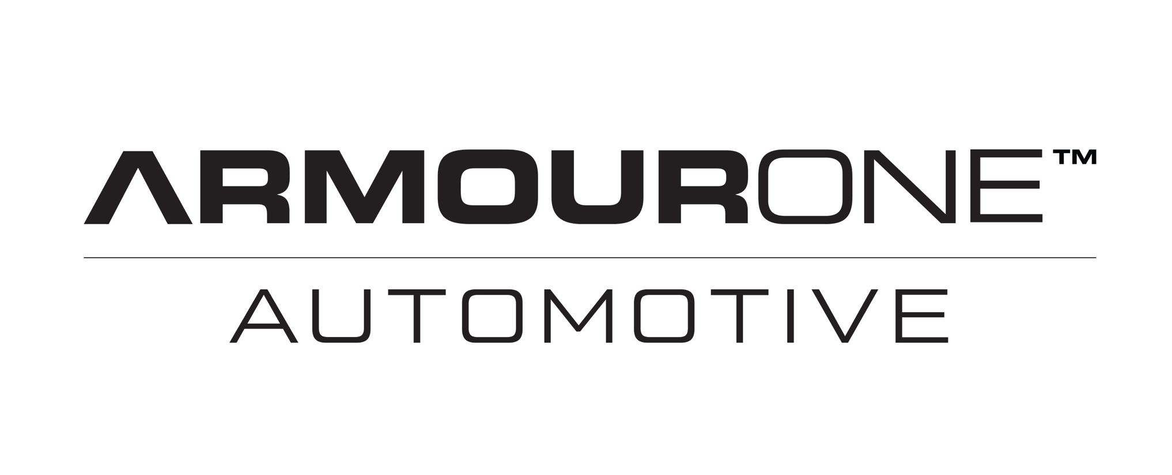
ARMOURONE AUTOMOTIVE PRODUCT APPLICATION AND MAINTANANCE GUIDE

THANK YOU FOR CHOOSING ARMOURONE TO PROTECT YOUR NEW INVESTMENT.

YOUR VEHICLE HAS BEEN TREATED WITH ONE OF OUR SPECIALISED SURFACE TREATMENT SYSTEMS. THIS MAY CONSIST OF THE FULL PROTECTIVE EXTERIOR & INTERIOR PACKAGE OR INDIVIDUAL TREATMENTS INCLUDING OUR EXTERIOR BODY ARMOUR POINTED BOROPHENE, OUR INTERIOR ARMOUR SURFACE PROTECTANT/ARMOURONE SAFE GLASS OR OUR WHEEL ARMOUR PROTECTIVE COATING.

KEEP CONTENTS AWAY FROM CHILDREN AT ALL TIMES

TYRE ARMOUR/BODY SHINE/ARMOUR CAR SHAMPOO/ FOAM ARMOUR/ARMOUR POLISH/ARMOUR BUG/TAR REMOVER ARE ALL WATER BASED BUT PLEASE USE CATUION WHEN APPLYING THEM.

WE RECOMMEND YOU APPLY OUR CUSTOMER COMPLIMENTRY MAINTENANCE PRODUCTS IN A SAFE MANNER. OUR COMPLIMENTRY PRODUCTS ARE ALL SAFE TO HANDLE BUT FOR YOUR SAFTEY WE RECOMMEND YOU USE CLOVES/BREATHING APPARATUS AND EYE PROTECTION AT ALL TIMES.
PLEASE DO NOT HESITATE IN CONTACTING US ANYTIME FOR FUTHER INFORMATION OR TO RECEIVE MDS MATERIAL ON 1300 605 997. OUR WEBSITE www.armourone.com.au has our full contact details.

ARMOURONE AUTOMOTIVE COMPLIMENTRY RANGE INCLUDES THE FOLLOWING (PLEASE BE AWARE CERTAIN PACKAGES WILL HAVE MORE PRODUCTS THAN OTHERS)

ARMOUR CAR SHAMPOO
ARMOUR BODY SHINE
ARMOUR SNOW FOAM
TYRE ARMOUR SHINE
ARMOUR POLISH
ARMOUR BUG/TAR REMOVER

ARMOUR CAR SHAMPOO FOR EXTERIOR CAR WASHING

WE HIGHLY RECOMMEND YOU DO NOT WASH YOUR CAR IN DIRECT SUNLIGHT OR WHEN THE SURFACE OF YOUR CAR IS HOT

ARMOUR CAR SHAMPOO IS AN EXTREEMLY HIGH QUALITY SHAMPOO AND CONDITIONER FOR YOUR VEHCILES EXTERIOR PAINTWORK. IT HAS BEEN ENGINEERED & DESIGNED TO FULLY COMPLIMENT YOUR VEHICLES APPLIED BODY ARMOUR POINTED BOROPHENE TREATMENT.

- Shake bottle well before use
- Rinse off excess dirt with a garden hose.
- Take cap off the Armour Car Shampoo and pour 50ml into a bucket of water with the wash glove provided.
- Wash the car with the hand wash mitt from the top surfaces down to the bottom.
- Always wash your bonnet/roof/boot and front first.
- Wash your windows/doors and the back of your vehicle next, and your wheels always last.
- Remember to rinse of exterior areas before soap has time to dry.
- If soap dries onto the surface simply wash over and hose off quickly.
- Spray the whole vehicle with clean water to remove excess soap.
- For best results after washing your vehicle, wipe over the surfaces of the car from top to bottom with a clean chamois or microfibre towel.

TYRE ARMOUR APPLICATION

TYRE ARMOUR HAS BEEN DESIGNED TO BE APPLIED BY HAND AND NOT WITH A SPRAY BOTTLE.
TYRE ARMOUR IS THE PERFECT COMPANION TO BEAUTIFY YOUR VEHCILES TYRES AFTER YOU HAVE WASHED IT.
PRIOR TO APPLICATION MAKE SURE YOUR TYRES ARE DRY.

HOW TO APPLY TYRE ARMOUR

- Firstly, ensure your tyres are clean/dry and free of any dirt/dust or debris.
- Shake bottle before use.
- Select your Tyre Armour Application pad.
- Take off the cap and pour a small amount of Tyre Armour (the size of a 50c piece) onto the application pad.
- Wipe the treated application pad around the tyre remembering not to hit the wheel if possible.
- Wipe over the whole tyre rubber with the treated pad remembering to add more Tyre Armour liquid for each tyre.
- If you wipe Tyre Armour onto your wheel accidently simply wipe it off with a clean microfibre cloth.
- Safely move the car forward or back to reach the full tyre surface.

ARMOUR BODY SHINE

ARMOUR BODY SHINE IS THE PERFECT COMPANION TO KEEP YOUR VEHICLES PAINTWORK, WINDOWS AND WHEELS LOOKING AMAZING 24/7.
ARMOUR BODY SHINE HAS BEEN SPECIFICALLY ENGINEERED TO COMPLEMENT OUR ARMOURONE SAFE GLASS/WHEEL AND BODY ARMOUR SURFACE TREATMEMNTS.
BODY SHINE WORKS BY NOT ONLY CLEANING SURFACES BUT ALSO LEAVING THEM WITH A MIRROR LIKE LOOK. MADE FROM QUALITY WAXES AND POLISHES ITS DESIGNED TO ENHANCE THE PROTECTIVE COATING ALREADY APPLIED.

PERFECT FOR A WATERLESS WASH OR TO CLEAN OFF BUGGS/ BIRD/BATT DROPPINGS

HOW TO APPLY ARMOUR BODY SHINE

FOR USE ON WINDOWS, PAINTED SURFACES AND WHEELS

Clean your vehicle first (it is recommended to wash your vehicle prior to applying Armour Body Shine) Unless using Armour Body Shine as a waterless wash

- Never apply to a hot surface or in direct sunlight.
- Shake bottle prior to use.
- It is recommended to wash your car first before applying Armour Body Shine.
- Unscrew the cap from the bottle and insert the black trigger spray.
- Ensure the trigger spray has been screwed on and the nozzle is adjusted to spray a fine mist.
- Spray contents directly onto a clean microfibre cloth.
- Wipe the coated cloth directly onto the surface until all residue is gone and a streak free finish appears.
- To clean off bugs simply spray the affected area and leave for a few minutes prior to wiping off.

USING BODY SHINE AS A WATERLESS WASH

WARNING IF USED ON HEVILY SOILED VEHICLES YOU MAY SCRATCH THE SURFACE

- Ensure the surface is free of excessive dirt/dust.
- Spray Armour Body Shine directly onto a cool surface ensuring you cover the surface fully in liquid.
- Wipe over with a clean microfibre cloth first and then another one to remove any left over product.
- Use the second cloth to buff the area to a brilliant shine.

ARMOUR BODY SHINE WHEEL APPLICATION

- Spray Armour Body Shine directly onto the wheels cool surface.
- Wipe over with a clean microfibre cloth.
- Polish to a shine.

ARMOUR BODY SHINE WINOW APPLICATION

- Spray Armour Body Shine directly onto a microfibre cloth and wipe over clean windows.
- Use a second cloth to polish the window to a beautiful shine.

ARMOUR POLISH APPLICATION

Armour Polish is a very high quality polymer based polish infused with minor powder cutting compounds. Use to polish any subtle scuffs/scratches or blemishes out of your paintwork.

- Shake bottle prior to use
- Make sure the affected area is clean before applying Armour Polish.
- Pour a small amount (the size of a ten cent piece) onto a clean microfibre applicator mitt.
- Rub the polish directly onto the blemish/scratch. Move the polish over the area in a circular motion for a few seconds.
- Wipe the surface with a clean microfibre cloth to see if the blemish has been removed.
- Repeat until you can see the affected area has improved.
- If the scratch or blemish remains after a couple of attempts, please see a detailing expert for rectification.

ARMOUR BUG AND TAR APPLICATION

Armour Bug and Tar surface cleaner is a mild clear liquid specifically designed to clean the most stubborn bugs and tar marks from your paint work.

- Clean the affected area first prior to using Armour Bug and Tar.
- Open the bottle and pour a small amount onto a clean microfibre cloth.
- Wipe over the affected area using a firm circular motion.
- It is perfectly fine to wipe over affected areas a number of times in order to remove the debris.
- Use Body Shine to wipe over the area applying Armour Bug and Tar remover to polish the surface to a glossy finish.

INTERIOR MAINTANCENCE

YOUR INTERIOR SHOULD ONLY REQUIRE MINIMUM CLEANING

Simply use a damp clean microfibre cloth to clean your dashboard or seats.

HOW TO MAINTAIN YOUR NEW VEHICLE INSIDE & OUT!

Your vehicle has been coated with the most state of the art surface treatments. Your vehicle will be extremely easy to maintain and keep its showroom shine.

- Wipe over the interior door trims, dash and seats with a clean damp cloth monthly to prevent dirt/dust build up.
- Vacuum carpets thoroughly
- Wipe over carpet and matts with a damp microfibre cloth to clean any dust or dirt left over after vacuuming.
- Remove any dirt/sun cream/spills with a damp clean microfibre cloth as soon as possible
- To remove stubborn stains from fabric or leather we recommend using a small amount of dishwashing liquid (only a teaspoon) in a litre of warm water and dampen a clean microfibre cloth. Wipe over the affected area with the damp cloth to remove the stain.
- We recommend you wash and chamois your car at least once a month with ArmourOne Shampoo or a quality vehicle wash.

- After washing your vehicle, it is extremely important to chamois it dry.

- Do not wash your vehicle with a broom or hard bristled brush especially from a DIY car wash.

- Do not wash your vehicle in direct sunlight or when the surface of your vehicle is hot.

- It is important to remove bird droppings/tree sap as soon as possible.

- Avoid using automatic car washes with harsh spinning actions as they may damage your vehicles paintwork.

ITEMS TO REMEMBER

- Always let your insurance company know you have had ArmourOne treatments applied to your new car.
- If you have an accident and panels have been resprayed we recommend your whole car should be re-treated.
- If you have any questions, please contact us anytime at enquiries@armourone.com.au
- You can transfer your warranty by emailing enquiries@armourone.com.au
- All exterior and interior treatments are applied by trained technicians. Warranties are not applicable for DIY application.

THANK YOU FOR TREATING YOUR NEW VEHICLE WITH ARMOURONE

